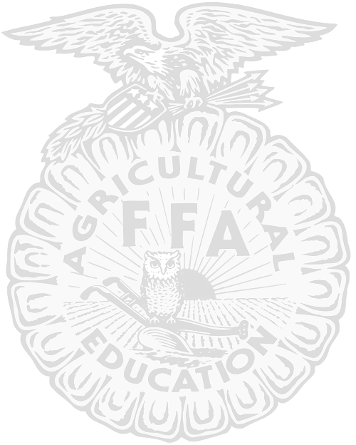
February 14-17, 2018
L.D. Robinson Pavilion ● Katy, Texas
Exhibitor’s Handbook
2017-2018 | Katy Independent School District FFA Livestock Show

STUDENT DIRECTORY INFORMATION

Each year, parents are required to select a privacy code for their children when signing their annual enrollment cards. Certain information about district students is considered directory information and will be released to anyone who follows the procedures for requesting the information unless the parent or guardian objects to the release of the directory information about the student.

Katy ISD has designated the following information as directory information: student name, address, telephone listing, and photograph, as well as, honors and awards received, dates of school attendance, grade level, and most recent educational institution attended, participation in officially recognized activities sports, and weight and height of members of athletic teams.

Parents must select one of the codes below:
A – All: My child’s directory information is public information and may be released to the public. It may be released to anyone making a public information request and may appear in school directories, other school publications, photographs, yearbooks, in a program for a performance (such as athletics, band, choir, etc.) on a District or campus Webpage, and in news releases.
N – None: My child's directory information is confidential and may not be released to the public. It may not appear in school directories, other school publications, yearbooks, class or organization photographs, in a program for a performance (such as athletics, band, choir, etc.), or in news releases.
O – Other: My child's directory information is confidential; my child's name, address, phone number, and/or picture may not appear in school directories or on a District or campus. Web page and may not be released to the public; however, name and/or picture, height/weight, organizational membership, and awards received may appear in yearbooks, school-confined publications, and in a program for a performance (such as athletics, band, choir, etc.), and may be included in professional school group or class photographs and limited information may be released to officially-designated vendors for school-related purposes (i.e. individual and group picture photographers, yearbook publisher, if necessary in identifying photos, providing order forms, etc.). Vendors will be under contract to not use or share student information for anything other than the purpose related to the school contract.

PUBLIC EVENTS

Please note that there are certain events that are considered public. Katy ISD is unable to prevent the media from taking pictures or videos of students participating in public events. For example, the FFA Livestock Show, Rodeo and Auction are considered to be events open to the public. As such, it is possible that your student may be photographed or approached by the media to provide information about FFA or a particular event. Parents who do not wish for their student to be interviewed by the media need to discuss their preference with their child so that they can appropriately respond if approached. It is unlikely, however, that consent will be requested for a photograph.

Information provided by: Bonnie Holland, Assistant Superintendent, Administration, Governance and Legal Affairs
Livestock Show Contacts
Dr. Sarah Martin, CTE Director (281) 396-2633 sarahjmartin@katyisd.org
Guy James, CTE Livestock Coordinator (281) 396-2638 guydjames@katyisd.org
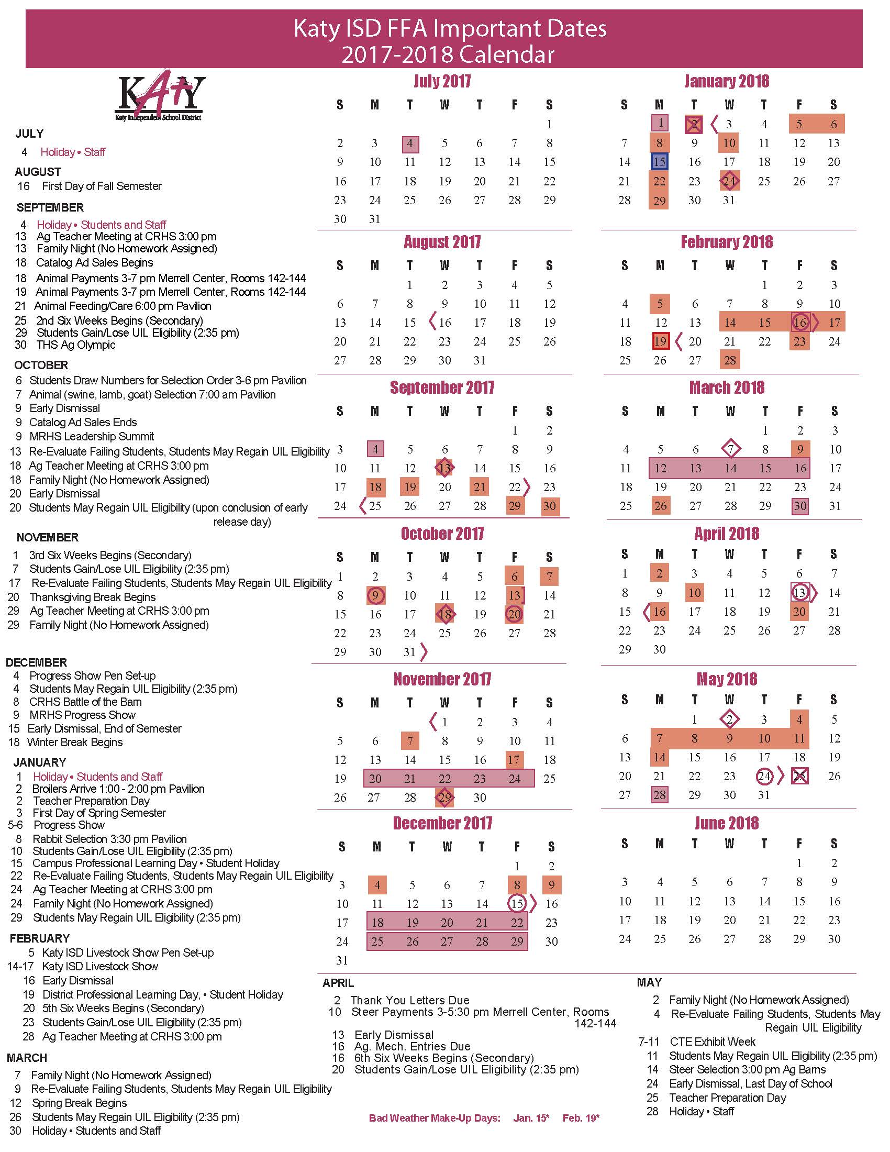
*Lamb and goat selection times are subject to change based upon the number of students choosing animals.

2018 Katy ISD FFA Livestock Show Schedule

Wednesday, February 14, 2018
8:00 AM - 12:00 PM – Weigh-in Swine
10:00 AM - Special Rodeo
Arrival of steers, goats and lambs by 2:00 PM
Species will weigh between 2:00 PM and 3:00 PM
4:00 PM - Rabbit Show
7:00 PM - Broiler Show

Thursday, February 15, 2018
8:00 AM - Swine Show

1:00 PM - Steer Show
7:00 PM - Rodeo Performance

Friday, February 16, 2018
7:30 AM - Goat Show
10:00 AM - Lamb Show
1:00 PM - Auction Sale Meeting – 142-144 - Merrell
7:00 PM - Rodeo Performance

Saturday, February 17, 2018
7:00 AM - Barn Sale
9:30 AM - Parade
11:00 AM - Buyers’ Luncheon
1:00 PM - Auction
7:00 PM - Rodeo

Sunday, February 18, 2018
1:00 PM – Only students in Livestock Auction are required to be at the pavilion on Sunday.

All students are responsible for attending meetings throughout the entire Livestock Show. Meetings will be announced at weigh-in. The pavilion will close each night at 7:00 PM. No one is allowed in the pavilion after 7:00 PM unless accompanied by a KISD representative. Saturday night the pavilion will close at 6:00 PM. The Barn Sale and Add-On table will close one (1) hour after the close of the auction.
General Rules

Katy ISD shall be the final authority of these rules and regulations and shall arbitrarily settle and determine all matters, questions, and differences in regard thereto or otherwise arising out of connection with, or incidental to the show.

- Only Katy ISD FFA dues paying members of good standing with their chapter and enrolled in classes of Agricultural Science at their campus (both fall and spring semesters) in Katy ISD are eligible to qualify as exhibitors. An exhibitor is a student who shows his or her animal at the Katy ISD FFA annual show.
- Students shall be eligible to attempt meeting qualifications for only four years and shall not exhibit livestock in the show for more than four years.
- All Katy ISD FFA members may begin meeting eligibility requirements for the 2018 show at the conclusion of the 2017 show. Each year’s activities will run show date to show date.
- All required fees, entries, animal costs, etc. must be paid by September 19, 2017 for exhibitors to be eligible for competition.
- University Interscholastic League rules of eligibility will apply to both the show and sale.
- If a student is assigned to homebound school and still enrolled in an Agricultural Science class, the student will not be eligible to show or participate in the barn sale.
- Any student who is suspended from school or assigned to OAC will be ineligible to show. Any student placed in ISS for more than three days or more than one time during the school year will be ineligible to show.
- A student violating show rules shall be required to immediately leave the show grounds. The student’s parents will be contacted. The animal will be sold for market price and the funds will be sent to the student.
- According to KISD policy extracurricular activities may set higher standards of dress code than campus standards. KISD exhibitors must adhere to the following rules at all KISD Livestock Show functions, including selection of animals, progress show, and the livestock show and sale.
- Girls will have neatly groomed hair with no unnatural color.
- Boys will have hair neatly groomed, off the ears and collar, and no unnatural color.
- Boy’s earrings are prohibited.
- All visible body piercings are prohibited. The only exception will be females with ears pierced.
- At the KISD progress show exhibitors must exhibit their projects in the progress show shirt, jeans/pants that are free of holes, and closed toe footwear.
- During the livestock show, exhibitors must be present in official dress during their species show, auction, and picture.
- Any violation of these rules will result in forfeiture of all show proceeds.
- Exhibitor Eligibility – Each exhibitor shall meet the following requirements:
  - Maintain accurate and up-to-date records of expense, income and other pertinent information.
  - Complete 10 community service hours approved by the AST prior to the Livestock Show.
  - In the first year of exhibition, recite the FFA Creed during the first semester of Ag enrollment.
  - First year exhibitors must complete the online Quality Counts Program (http://qualitycounts.tamu.edu/) as instructed to do so by the AST, and turn in the required documentation on or before the end of 1st semester to their AST.
  - Participate in at least two activities above the chapter level.
  - Participate in chapter fundraising activities and have $500 in gross sales annually, which must include at least one catalog ad. This entitles each Green hand (first year) member to a chapter purchased FFA jacket.
- When progress shows are held for specific species (steers, hogs, goats, lambs), the exhibitors are encouraged to participate and shall be responsible for the transportation of their livestock.
- All FFA meetings and work assignments held during show week shall be attended by all FFA members. Activities such as picture taking, parade assignments, hauling equipment and supplies, and clean-up details are included. Monetary fees ($25.00 or as stated) will be levied for missing any assignments.
- Each exhibitor must show his/her own animal in the show ring during the Katy ISD FFA Livestock Show unless an emergency arises and substitutions are pre-approved by the Agricultural Science Teachers. The substitution must be from the exhibitor’s chapter and be show eligible.
- Upon receiving their livestock show pictures, students will have two (2) weeks to complete their picture delivery and return signed documentation to their AST. Failure to meet this deadline will result in a late penalty of $25 per day.
- Each exhibitor must write a buyer “Thank You” letter, present that letter to his/her Agricultural Science Teacher for approval, and receive that approval by April 2, 2018 to be eligible to receive his/her Livestock Show check. Failure to meet this deadline will result in a late penalty of $25 per day and delayed Livestock Show checks.
- During the show, on weekdays, students are expected to be at the show facility during normal school hours unless they have pre-approval from their Ag Science Teacher.
- During the livestock show, the barn will open at 6:00 am and close nightly at 7:00 PM. At 6:00 pm Saturday all animals will remain in their pens and students and parents should exit the building. All feeding, care, etc. must be done prior to this time each day.
- Projects will be pre-stalled at the progress show and the livestock show. Exhibitors may be required to share pens and should make plans accordingly. Katy ISD does not guarantee a pen for each project at the show facility. One bag of shavings will be provided per pen and three bags per steer. Any additional shavings will be up to the exhibitor.
- Any student who withdraws from enrollment in Katy ISD for any reason will not be eligible to exhibit a market animal at that school year’s show.
- To be an exhibitor of any Katy ISD FFA Chapter, any animal project, local or major, must be housed within the Katy ISD boundaries, unless it is his/her primary residence.

- All animal pen(s) must be clean at all times. Any animal not fed, watered and cared for daily
will be removed from the facility at the owner’s expense. Steps followed when failure to maintain proper care of pen area and animal care are:
*First offense – The student will receive a letter from the AST, which constitutes a warning, and the problem must be remedied within two (2) days of letter’s date to the satisfaction of the Agricultural Science Teacher. The letter will be signed by both the student and the parent, and filed in the CTE office of Katy ISD. A copy of the letter will be made available to the campus administrator of the student.
*Second Offense – Will follow the same steps as above, but will be considered a final warning.
*Third Offense - The student will be evicted from the facility and the animal will be removed from the premises at the owner’s expense.
*Fourth Offense – If the animal has not been removed from the barn within 72 hours of having been served an eviction notice via certified mail, the animal will be sold at auction. If the animal was sponsored by a scramble or non-profit organization, any residual funds (after all outstanding dues and fees are paid) shall be returned to that organization. If the animal was not purchased by a scramble or non-profit organization, any residual funds (after outstanding dues and fees are paid) shall be donated to the student’s FFA chapter.

Species Rules

Katy ISD shall be the final authority of these rules and regulations and shall arbitrarily settle and determine all matters, questions, and differences in regard thereto or otherwise arising out of connection with, or incidental to the show.

- Official selection dates and times will be set by Katy ISD, and students must attend unless preapproval is granted by the Katy ISD Livestock Show Committee.
- All KISD projects will be purchased cooperatively by the Katy ISD FFA Livestock Show Committee. Students will be required to pay the non-refundable fees for animals by deadlines set annually by the Katy ISD FFA Livestock Show Committee. The students, accompanied by the Ag teachers, shall draw lots for large animals to determine the order of selection and select their choices from a group of animals that will exceed the total number of buyers.
- October 6, 2017 from 3:00-6:00 pm at the pavilion, students will draw numbers to determine selection order. Students will draw numbers as they arrive in no certain order. If a student cannot make the drawing of numbers, the Ag teacher will draw for the student.
- Each year, an exhibitor may purchase two animals (or two lots of animals in the case of rabbits and broilers) of one particular species. Only one animal (or pen) can be shown by an exhibitor at the Katy ISD FFA Livestock Show each year.
- Any medications administered to animal projects must meet USDA guidelines and any surgical alterations must be approved by the supervising Ag Science Teacher. All species are subject to a drug screening.
- All care of the projects, both prior to and during the livestock show, must be approved by the appropriate AST.
- Classes will be broken at the show, as needed, by the Katy ISD Livestock Show Committee.
- Only Katy ISD academically eligible students may bring projects to the Katy ISD Livestock Show. These projects must have current Katy ISD FFA Livestock Show identification to be exhibited.
- All projects exhibited at the KISD Livestock Show are eligible for the barn sale. KISD does not guarantee a buyer in either sale. If projects are not sold by the close of the barn sale, remaining steers, goats, lambs, and swine will be sold for market value to a livestock commission company. Remaining rabbits and broilers will have no market value, hence they will receive no market price. At the conclusion of the premium auction, if the add-on’s for a barn sale project exceed the barn sale price, the project will be considered sold and will become the property of KISD, with any resale proceeds back to the chapter of origin.
- In the event that an animal dies from natural causes after weighing in at the show and before the animals have been dispersed the final day:
- The student will receive all add-on monies.
- If the student had finished showing, made the auction, and the animal dies, the student will be allowed to walk through the auction.
- After September 19, 2017 students will not be allowed to purchase or show another KISD animal during the show year for KISD Livestock Show
- Prospective exhibitors must meet the following financial responsibilities:

All Exhibitors: $25 Non-refundable entry fee due by 9/19/17
Steer: $2300* per animal submitted by 4/11/17
Lamb: $350* per animal submitted by 9/18-19/17
Goat: $350* per animal submitted by 9/18-19/17
Hog: $300* per animal submitted by 9/18-19/17
Rabbits: $250* per box of 5 submitted by 9/18-19/17
Broilers: $2.00* per bird (25 minimum) submitted by 9/18-19/17
*Prices of animals may change based on market conditions.

No refunds/reimbursements will be given once entries are purchased.
No exhibitor may exhibit a project unless he/she adheres to these deadlines.

Market Lambs
- Lambs will be slick shorn. Only 30 minutes will be given for students to correct the shear rule.
- Ewes or weathers may be shown.
- The use of a hot shot or any electric prod is prohibited at the Livestock Show.

Market Hogs
- Open gilts or barrows may be shown.

Market Steers
- The Katy ISD FFA Progress Show will be a “Blow and Go Show” for steers.
- Steers will be slick shorn for the Katy ISD FFA Livestock Show not to exceed ¼” of hair on any part of their body excluding the tail switch. Only 30 minutes will be given for students to correct the shear rule.

Market Goats
- Goats must be exhibited with only a collar or chain. No harnesses or halters are allowed.
- Goats are to be summer clipped from the knee and hock up, not to exceed 3/8” of hair on any part of their body excluding the tail. Only 30 minutes will be given for students to correct the shear rule.

Broilers
- Broilers will be shown in a pen of three at the Katy ISD FFA Livestock Show.
- Broilers will be purchased in lots of 25. Each exhibitor may purchase up to two lots of 25, or 50 birds.
- Broilers will be wing banded upon delivery, and those that show at the Katy ISD FFA Livestock Show must have the appropriate band present on the bird.
- All broilers will go through a sift before the show begins. During the sift, the following items will be checked:
- Wing band numbers must match student’s registration wing band numbers. Broilers missing wing bands will not be allowed to show.
- Bruising on breast, wing area and broken bones. Bruising and broken bone broilers will be sifted at the judge’s discretion.
- The broilers presented to the Judge/Sifter will be the exhibitor’s “Official Entry”. If a bird is sifted, the exhibitor can replace with 1 alternate bird and re-enter the sift line. If an exhibitor’s pen is sifted twice, the exhibitor will be disqualified from showing.
- The use of Paylean or any other USDA banned feed additive is prohibited.
- Following the broiler show, all show birds are property of Katy ISD. Birds will go straight from the show ring to the loading trailer for processing at the conclusion of the show.
- It will be the responsibility of the student’s that win Grand and Reserve Champion to furnish an alternate broiler that will stay after the show only for the sale. Shavings, water, and feed will be provided by the student.
- Students will be responsible for obtaining the birds from their Ag teacher and delivering the processed birds to the buyer within two (2) weeks after the show. A $25 per day late fee will be assessed for not delivering the birds within the two (2) week window.

Rabbits
- Rabbits will be shown in a pen of three at the Katy ISD FFA Livestock Show.
- Rabbits will be purchased by Katy ISD in meat pens of five (5). Each exhibitor can purchase up to two (2) pens. Rabbits will be tattooed before distribution to exhibitors. Only those rabbits having the required tattoos will be allowed to show.
- Rabbits will be weighed at check in. Each rabbit will be weighed once to the first decimal. Ex. 5.2
- Exhibitors must bring feed and water containers to the show for their pens.
- Once the rabbits enter the show the rabbits become the property of Katy ISD Livestock Show and will be sent to processing when the rabbit show is complete.
- Exhibitors are responsible for delivering the processed rabbits to the buyer. Students will be responsible for obtaining the rabbits from their Ag teacher and delivering the processed rabbits to the buyer within two (2) weeks after the show. A $25 per day late fee will be assessed for not delivering the rabbits within the two (2) week window.
- One alternate rabbit from Grand and Reserve will stay after the show only for the sale. It will be the student’s responsibility to provide water, feed, and care for the champion rabbit’s until the conclusion of the auction on Saturday.

Sale and Add-On Rules

Katy ISD shall be the final authority of these rules and regulations and shall arbitrarily settle and determine all matters, questions, and differences in regard thereto or otherwise arising out of connection with, or incidental to the show.

- The Katy ISD FFA Livestock Show and Sale is a terminal show. All projects exhibited at the show will be processed and delivered according to the buyer’s choice, per the Katy ISD FFA Livestock Auction Form. Absolutely no livestock will be allowed to be returned to the exhibitor’s possession. Any students found to be in violation of this rule will be banned from future exhibition in the Katy ISD FFA Livestock Show.
- The Katy ISD Livestock Show Auction will consist of 118 lots annually. The Grand and Reserve Showmanship winner of goats, lambs, steers and hogs will be sold after the reserve champions, and be noted as such in the sale footnotes.

- All projects exhibited at the KISD Livestock Show are eligible for the barn sale. KISD does not guarantee a buyer in either sale. If projects are not sold by the close of the barn sale, remaining steers, goats, lambs, and swine will be sold for market value to a livestock commission company. Remaining rabbits and broilers will have no market value, hence they will receive no market price. At the conclusion of the premium auction, if the add-on’s for a barn sale project exceed the barn sale price, the project will be considered sold and will become the property of KISD, with any resale proceeds back to the chapter of origin.
- The barn sale will begin at 7:00 AM on Saturday, February 17, 2018 and will conclude one (1) hour after the Auction is completed. Barn sale prices will be set at the following for the 2018 Show and Sale:
  - Steers $2300
  - Lambs $350
  - Goats $350
  - Hogs $400
  - Rabbit $100
  - Broilers $100
- The judge of each species will set the sale order.
- The Grand Champion and Reserve Champion of each division will automatically be sold in the premium sale. All other entries will be placed in sale order by the respective judges.
- The minimum number of steers in the auction will be determined by multiplying 50% (.5) by the number of steers weighing in at the show.
- The number of rabbit lots will be capped at 10.
- The balance of the auction sale lots will be determined by the number of students weighing in lambs, goats, swine, and checking in broilers at the show and dividing these entries by the remaining available sale lots (minus steer and rabbit lots) to give a sale percentage for each species.
- The Grand Champion price will set the sale cap for each species. The Reserve Champion and each subsequent lot of that species may sell for a maximum of $1 less than the Grand Champion. These limitations will pertain to auction prices only, not add-ons.
- There will be no specific notes or comments made on exhibitors from the auction block. The animals must be presented in the auction ring in the same manner as they were shown in the show ring. Example: no glitter, no baskets, etc.
- Add-on donations for all exhibitors will be accepted during the show at the add-on table.
No add-on will be accepted after one (1) hour following the close of the auction.
- All exhibitors will pay a commission of 8% (.08) on all sale items, including add-ons. This commission will be used for administrative costs for the progress show and livestock show.
- Phone in add-on will be taken February 1-10, 2018.
- The process for exhibitor checks will start as soon as 92% of the sale, add-on’s and barn sale have been collected.

Agricultural Science Facility Regulations Agreement

The purpose of the Katy ISD Agricultural facility located at Katy-Hockley Road and Beckendorff Road is to provide an extension of the classroom to be utilized for the students’ Supervised Agricultural Experience Programs (SAEP). For student convenience, Katy ISD will provide morning bus service to and from the facility originating at each high school campus and returning to that same campus. This bus service will be provided starting the first class day of Katy ISD schools and end the day after the Katy ISD Livestock Show and Sale annually. On days that students ride the bus, they are expected to ride both to and from the project center unless pre-approval is granted by the AST. Katy ISD Student Code of Conduct applies as it relates to bus privileges.

In order for all parties to best utilize the Agricultural Science facilities and to ensure the safety of the students, animals and others on the property, the following regulations must be followed. To ensure compliance, Katy ISD employees, including Agricultural Science Teachers and school administrators, will monitor compliance of facility regulations and the operations of the facility.

Based on the respect for each schools’ traditions, standards and expectations, the rules and guidelines have been established by Katy ISD. Due to the uniqueness of the individual schools and the needs of the individual students, the individual Agricultural Science Teachers (AST) may make decisions based on the best interest of the District, the school, the student, and the animal(s).

All participants will comply with the following regulations and criteria.
1. As a Katy ISD facility supporting school-related activities, the most recent Katy ISD Student Handbook and the Katy ISD Discipline Management Plan and Student Code of Conduct will apply.
2. For security purposes, the facility will be open between 5:00 AM and 9:00 PM.
3. The Agricultural Science Teachers will monitor all guidelines and criteria closely. Ethical and humane treatment of animals and violation of regulations will not be compromised, and the offense period outlined below will apply.
4. The student must be a dues paying Katy ISD FFA member in good standing to utilize the facility. Guests must have prior permission to enter the complex. The student is responsible for his/her family and guest(s) at all times. If the guest violates the rules of the Agricultural Science Facility, it will be treated as though the student violated the rules.
5. Drive and park in designated areas. Students and parents may use either entrance and park in the FRONT parking lot only. The back of the barns are for unloading and emergency parking only.
Actions that will be followed when parking rules are violated:
First Offense – The student will receive a letter from the AST, which constitutes a warning. The letter will be signed by both the student and parent, and will be filed in the CTE office of Katy ISD.
Second Offense – The individual in violation will be turned in to the KISD CTE office where a second email, letter, or both will be sent. This will be considered a final warning.
Third Offense – All gate cards will be taken up by the AST, the cards will be deactivated, and student and family members will not be permitted to drive a vehicle on the Agricultural Facility premises.
6. Keep animal pen(s) clean at all times. Any animal not fed, watered and cared for daily will be removed from the facility at the owner’s expense. Steps followed when failure to maintain proper care of pen area and animal care are:
*First Offense – The student will receive a letter from the AST, which constitutes a warning, and the problem must be remedied within two (2) days of letter’s date to the satisfaction of the Agricultural Science Teacher. The letter will be signed by both the student and the parent, and filed in the CTE office of Katy ISD. A copy of the letter will be made available to the campus administrator of the student.
*Second Offense – Will follow the same steps as above, but will be considered a final warning.
*Third Offense - The student will be evicted from the facility and the animal will be removed from the premises at the owner’s expense. If the animal has not been removed from the barn within 72 hours the animal will be sold at auction. Any residual funds (after outstanding dues and fees are paid) shall be donated to the student’s FFA chapter.
7. Students will provide their own animal care equipment.
8. No male breeding animals are allowed at the facility. Heifers no longer eligible to compete at approved shows must be removed from the facility within two (2) weeks after the last show for which they are eligible to compete.
9. If a student becomes ineligible to show, he/she will have 10 days, from the day they became ineligible, to remove his/her animal from the ag facility.
10. If a student is evicted from the facility, he/she will not be allowed back on the premises.
11. All manure and feedstuffs must be properly disposed of in the approved designated areas.
12. Tack rooms are to be kept neat and clean. No hay will be allowed into the tack rooms. Any valuables are suggested to be brought to and from home as needed. The school district and its employees are not responsible for theft or damage. Students will not be permitted to bring in tack not approved by the Agricultural Science Teacher. The safety, sanitation and the appearance of the barn are a priority.
13. The student is responsible for cleaning and maintaining the project area (e.g. pen) at all times. No modifications may be made to the existing structure. At certain times of the year, students may be required to clean their project area and assist others in cleaning the facility as a whole.
14. Priority for space will be given to Katy ISD FFA show animals.
15. A student may have no more than four (4) animals at the facility at one time.
16. All students’ projects are under the direct supervision of their Agricultural Science Teacher.
17. The use of power equipment such as tractors, bobcats, other front-end loader, etc. by students is NOT allowed at the facility.
18. Pen rent must be paid in full prior to placing the animal at the facility at a rate of $20.00 per month.
19. No heat lamps are allowed in the barns at any time.
20. Projects must be related to FFA. No 4-H projects. Jr. FFA projects may be housed at the discretion of the AST, based on pen availability.
The animals listed below may be kept at the facility:
Junior Breeding Heifers Junior Market Show Steers
Junior Market Show Hogs Junior Market Show Lambs
Junior Market Show Goats
21. Remove animals, clean pen out within two (2) weeks after exhibiting the animal at the designated show. If a student fails to clean out his/her pen within the two (2) week time frame, he/she will forfeit all proceeds acquired from the show to their respective chapters.
22. Animals are to be washed in designated areas only.
23. At ALL TIMES, students are to remain in their designated barn. At NO TIME, are students allowed in other high school barns unless asked to do so by an AST.
24. Students will be required to purchase security cards at the rate of $5.00 each. Each card, after the initial two (2) cards have been purchased, may be replaced for $5.00 each. All exhibitor cards will be deactivated after the Katy ISD Livestock Show annually, and re-activated as needed.
25. The student is to respect the value of the Katy ISD Agricultural Science Facility. Any defacing of property or equipment will mean dismissal from the complex IMMEDIATELY.
26. Passageways, including door openings, are not to be cluttered with boxes, equipment or animals. Both routine and emergency traffic must be able to move efficiently.
27. All broken or stolen equipment is to be reported immediately. All equipment is to be cleaned and returned to the proper storage area after each use. All wheelbarrows WILL be emptied after each use.
28. No glass containers are allowed at the barn complex. Broken glass can cause severe damage to a student or project.
29. No pets are allowed at the barn.
30. Upon graduation, students will no longer have use of the project facility.
31. Neither KATY ISD, Cinco Ranch High School FFA and Booster Club, Katy High School FFA and Booster Club, Mayde Creek High School FFA and Booster Club, Morton Ranch High School FFA and Booster Club, Taylor High School FFA and Booster Club, Seven Lakes FFA and Booster Club, Tompkins High School FFA and Booster Club, Paetow High School FFA and Booster Club or the Katy ISD Agricultural Science Teachers nor any school official will be responsible for injury to or death of any project animal while it is on school property or any other property.

